Documentation of design and process

# Conception:

In the initial brainstorming stage of our project, the education application for kids was agreed upon unanimously as the one that we wanted to create. We each had an idea of what it would look like and how it would work, therefore we started a mind map of the ideas to help choose the best options. We produced a rough draft of what we wanted the app to achieve and thought of ways to make sure that goal was reached.

See Appendix 1 for a copy of our initial ideas document.

# Personas:

Since none of us were parents or children under the age of five we had to go about created personas and templates for the users that the app was aimed towards. Every detail had to be taken into account, from the free time the parent had, to the reason the child was using the app, or even if the goal of the app is possible if it is aimed towards the current target market. In appendices 2a and 2b, the personas that we created can be found. We put in as much detail as we could and set off to tailor the app to the needs of the target market using the personas as a guide. For example we knew the app could not be difficult to the point where the child would not find it entertaining but it also could not be too simple as the child would not learn anything.

# Prototypes and Wireframes:

As seen in Appendix 4, we produced wireframes for what we thought could be the layout for the application. We changed the places of the buttons around on each page so the user would understand the page has changed, from these prototypes we were able to create a functioning beta application on which to improve upon. A simple, easy to navigate and consistent layout had to be created to adhere to the needs of the child using it or the parent. Both are important in this case due to the fact that the parent is one that will download the app as the child is too young who in turn needs to be able to use the application easily.

# User testing:

We tested the app with a number of members of the core target audience and with parents to ensure that we were meeting their needs. Below are some examples of the issues raised and the steps for resolution that we took

|  |  |
| --- | --- |
| Problem | Solution |
| Child clicked on the answer to the question multiple times in succession and it added more than 1 point to their score for the same question | Added a boolean variable “answerAllowed” to check against, which changes to false when an answer has been tapped |
| Child did not hear the sound for the picture the first time (e.g. they were distracted), but they needed to hear it again without go back and starting again | The image is now tappable and will play the sound again upon tapping |
| Child found it difficult to tap buttons that control onscreen elements | The size of icons and fonts on screen were increased to make the app easier to use |
| Some alphabet images were found to be ambiguous. In particular there existed a red cross icon for the word red and a yellow star for the word yellow | Removed the offending images and replaced with much simpler designs |
| The existence of swipe gestures for transitioning between learning section images were non-obvious and difficult for child to use | Removed the feature from the app pending the results of further testing |
|  |  |

# Appendices

## Appendix 1 – Design Ideas

# Week 1 Ideas

We are making an educational media app for children. We will be targeting it primarily at children under five years of age.

It will focus on basic maths, alphabet and spelling.

## Alphabet

* Learning letters of the alphabet with pictures that start with that letter
* Word selection that start with the letters of alphabet
* Basic spelling tasks, e.g. name the animal

## Maths

* Introduce the numbers 0 through 20 along with the written equivalents
* Basic arithmetic, such as addition and subtraction

## Aesthetics

* Want to use vibrant colours to attract younger audiences
* Large fonts
* Fun audio to hold their attention
* Lots of images to reinforce learning and keep fun
* Cartoony representations of real life objects

## UI

* Simple navigation so that it is easy for young users
* Optimise for smartphone, but use responsive design so that it could work on a tablet as well.

## Appendix 2a – Child Persona

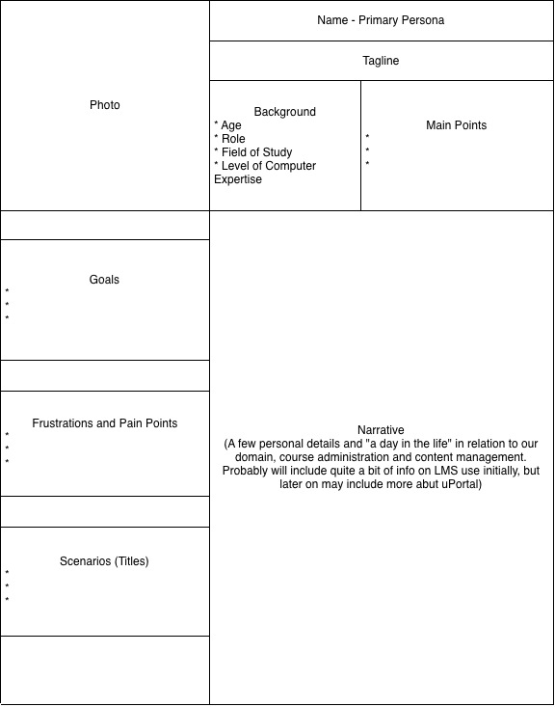

**Child**

**Background**

* 4 years old
* Minimal exposure to technology
* Likes apples

**Scenarios (Titles)**

* At home
* In car
* Family outings

**Frustrations and Pain Points**

* Boredom
* Uninteresting activities
* Difficult activities

**Goals**

* To be entertained
* To learn
* To play

**Narrative**

* Wake up
* Eat
* Wait for parent to take them to school (ample time to fill)
* In car (more free time)
* School (teacher could use it to teach the kids)
* On the way home (more time to fill in car)
* Time to fill before sleep

**Main points**

* Needs to be entertained
* Learn something
* Wants something to do on her own

**Tilly**

## Appendix 2b – Parent Persona

**Narrative**

* Wake up
* Eat
* Get child ready for school
* Get ready for work
* Take child to school
* Go to work(small 2 minute breaks)
* Lunch (window of free time)
* Finish work
* Collect child (window of time waiting for child)
* Go home
* Parent responsibilities (aka homework/play)
* Prepare dinner
* Eat
* Put child to bed
* Evening relax (another window of time to lookup)
* Go to bed

**Middle class parent**

**Main points**

* Need something to occupy child’s time but not waste it
* Wants to ensure a rounded education for child

**Goals**

* To improve child education
* Entertain child

**Frustrations and Pain Points**

* Apps that are not educational
* Does not occupy child’s time
* Too hard for child to use
* Not fun enough for child

**Scenarios (Titles)**

* At home
* In car
* Family outings

**Background**

* 32
* parent
* low level professional

**Rosie (Tilly’s mum)**

## Appendix 4 – Initial Wireframes

